ENG1D KCI Speak Webquest

- Define censorship.
- Follow this link, and define consent.
- Follow this link to read an excerpt from the author’s blog when the book was first being considered for banning in 2008.
- What is Halse’s response to the call to ban the book?
- Follow this link to read an article about the challenge to ban the book in 2010.
- What is the hashtag in response to the calls to ban the book?
- What does Halse find disgusting about Scroggins’ calling the book “pornographic”?
- What message to girls / women / victims of sexual assault would you tweet with the hashtag #speakloudly?
- Review the following infographic. Why do you think so few sexual assaults are prosecuted each year in Canada?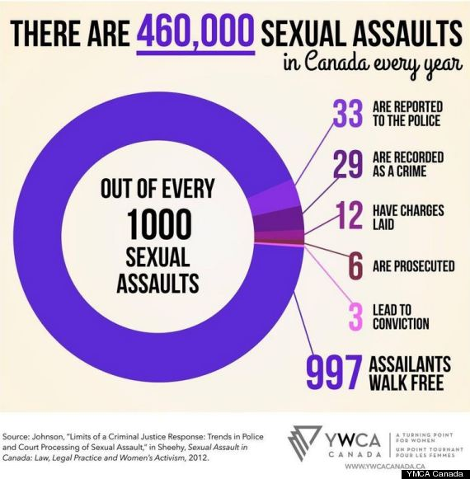
- Review this infographic. Why do you think so many victims know their assailants?
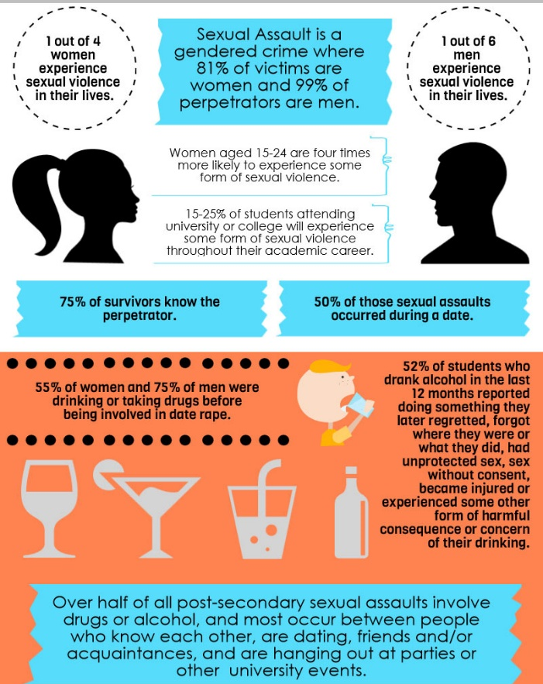

- Visit this page. List some of the Dos and Don’ts to avoid assaulting someone/being assaulted.
- Explain your reaction to the sexual assault stats found here, or to one of the Myths and Facts found here.

