Hello Grade 12 students,
Its me its you its us. Gimme a minute while I take attendance and then we’ll do three week weekend highlights.
This is an overview of your work for the week. When you are done, if able, upload pictures of your work to the assignment in Edsby called Week 1 Fossil Fuels Intro.
- Make notes from the two notes on Oil and Natural Gas.
- Read the attached resource on Oil Spills.
- Answer the attached questions. You may type the answers into a document or write them by hand. Use specific details.
- Read the Introductory materials on the oil spill disaster known as Deepwater Horizon.
- Listen and take notes on key ideas from the CBC News in Review segment on the oil spill in the Gulf of Mexico. You may find it here. You can enable Closed Captioning. It is about 15 minutes long.
- Answer the attached questions. You may type the answers into a document or write them by hand. Use specific details.
- Write a specific and detailed paragraph explaining what you already know about oil industry, spills, extraction, markets, etc in Canada right now, or what you know about oil globally, or what you want to learn, or how oil affects your life. You can include a collage of pictures at the end of the paragraph if that helps you express your thinking. This will be submitted separately on Edsby to an assignment called Week 1 Oil Paragraph.

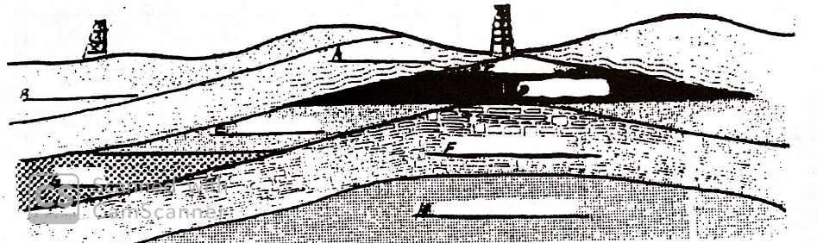
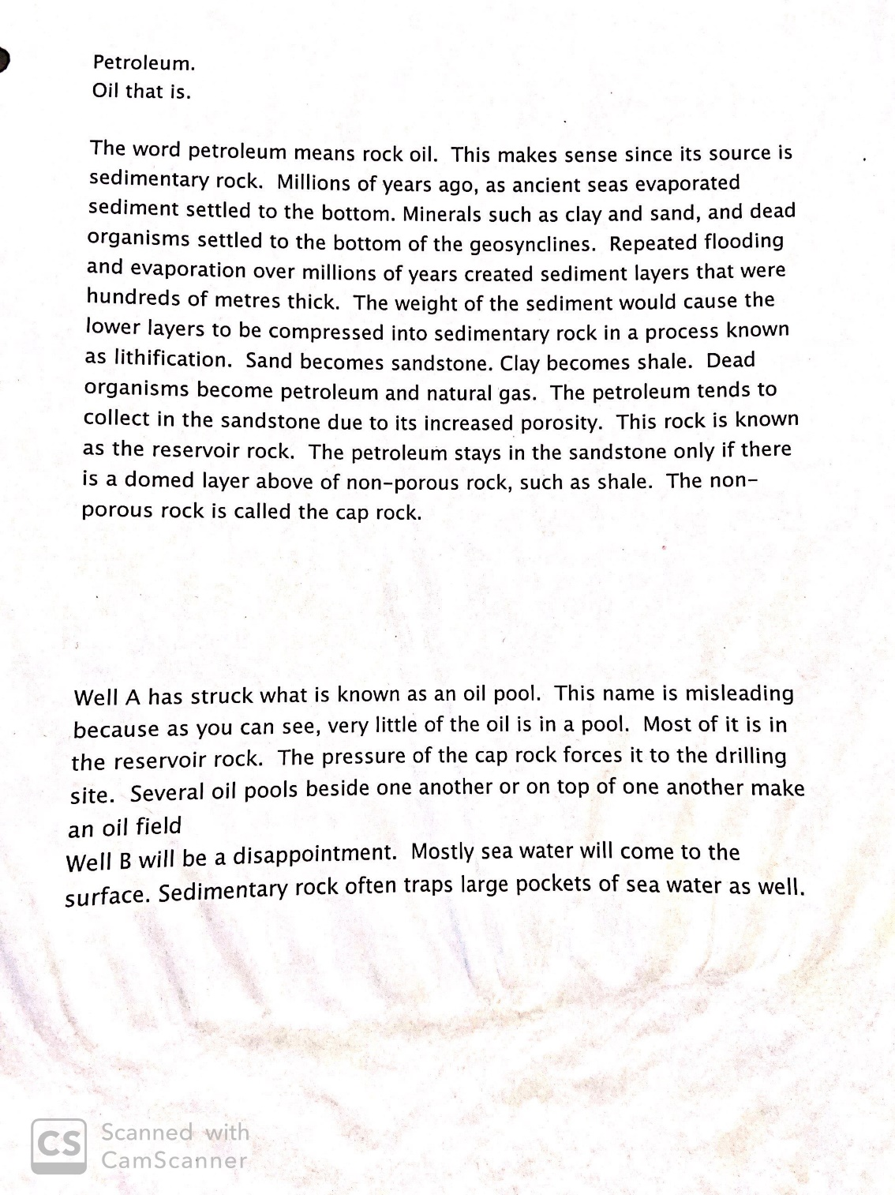

WELL B WELL A

THE TERMS IN DESCENDING ORDER
- Cap rock
- Horizon of soil
- Gas *this one is right under the well
- Oil Pool
- Reservoir rock
- Cap rock
- Water
- Bedrock
**You only need to know A, C, D, E, G.
