Hello Grade 9 students
Its me its you its us. Gimme a minute while I take attendance and then we’ll do three week weekend highlights.
This is an overview of your work for the week. When you are done, if able, upload pictures of your work to the assignment in Edsby called Week 1 Population.
- Read and take notes on key terms and ideas from the pages from the textbook attached below (pp 168-173). This will remind you of the things we were talking about in our Demographics unit.
- Use the data from Figure 15-9 from page 176 (also attached below) and complete the population pyramid for Canada in 1881 on the provided graph sheet. If you cannot print the sheet, you can just recreate it by hand with a ruler on a piece of lined paper.
- There are two handouts attached – one on Population Distribution and one on Population Distribution. Complete them both – right in the document or print out and by hand.
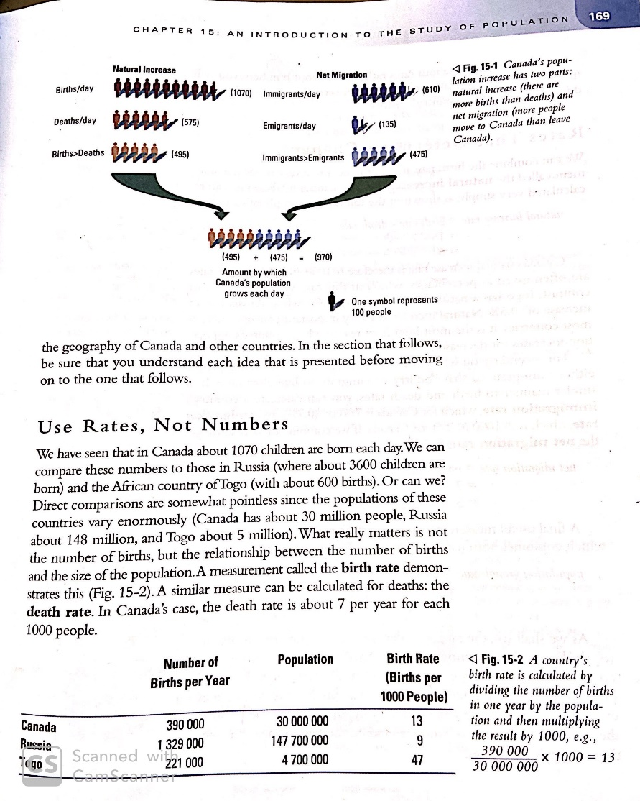
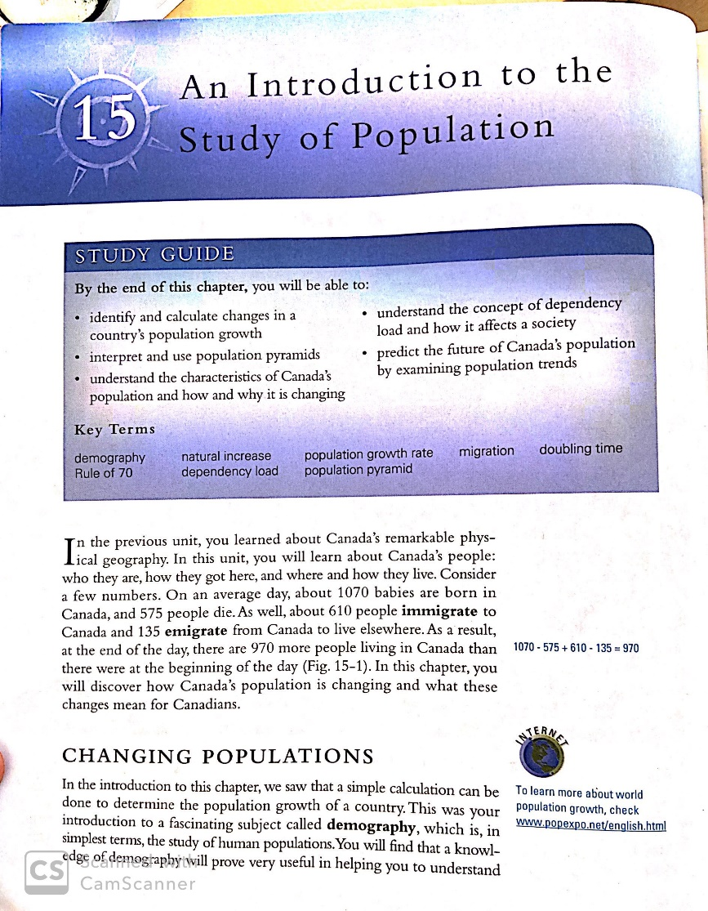

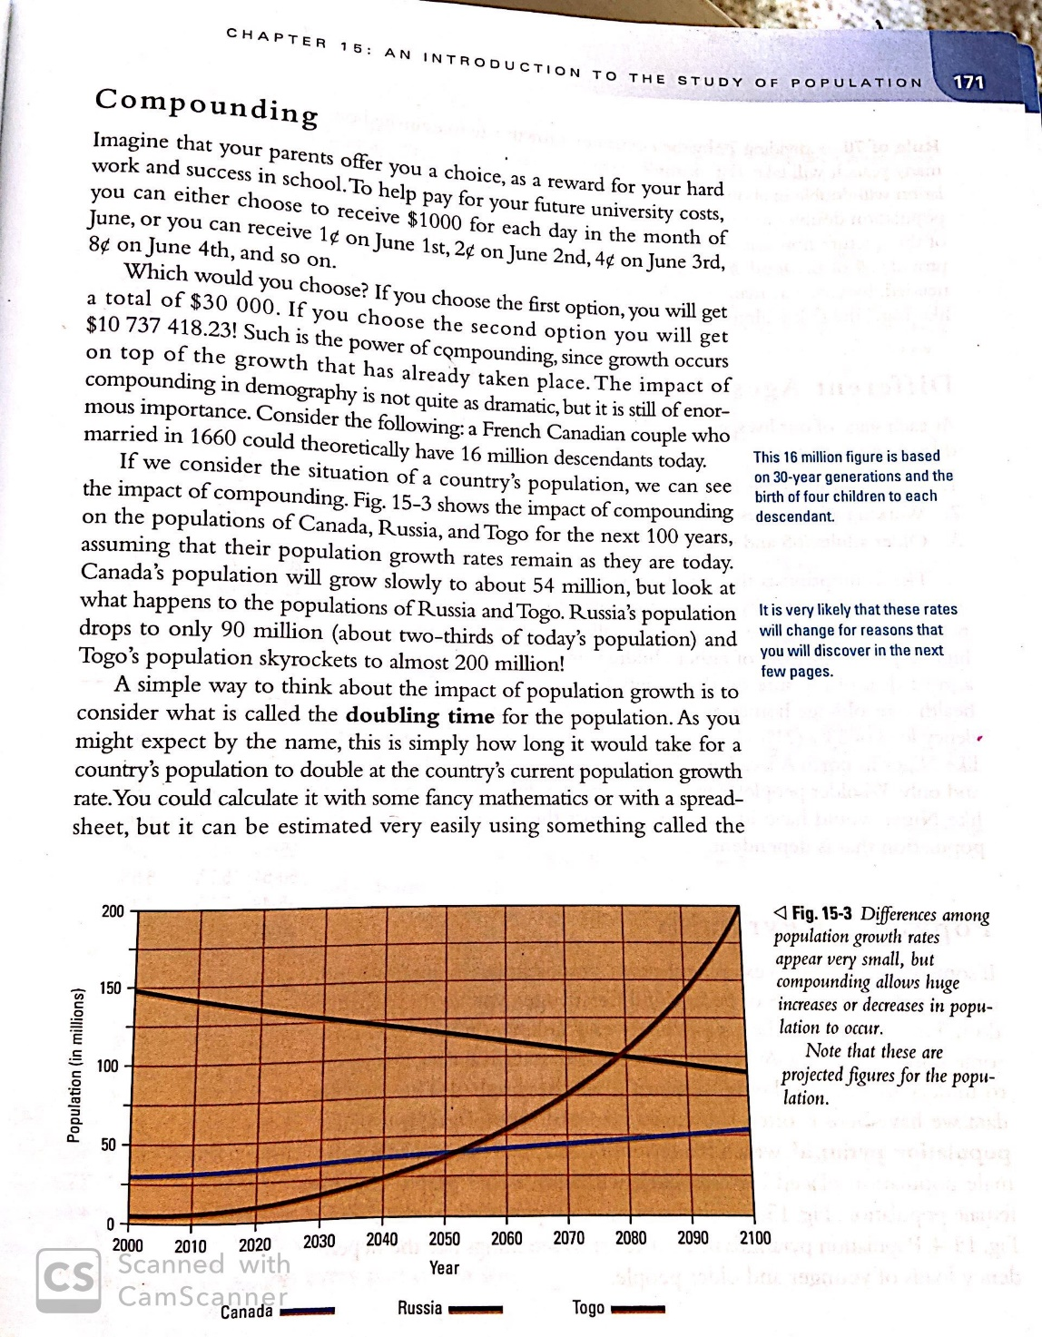
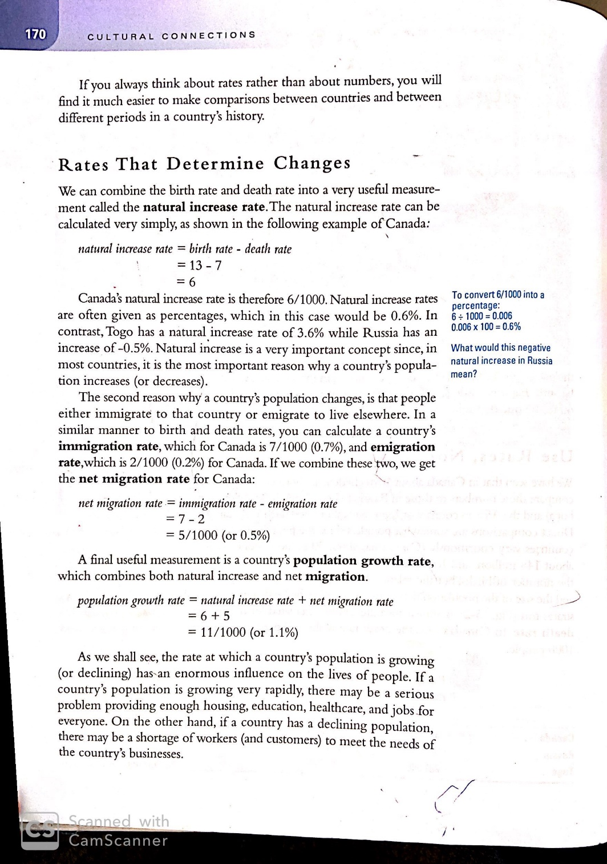

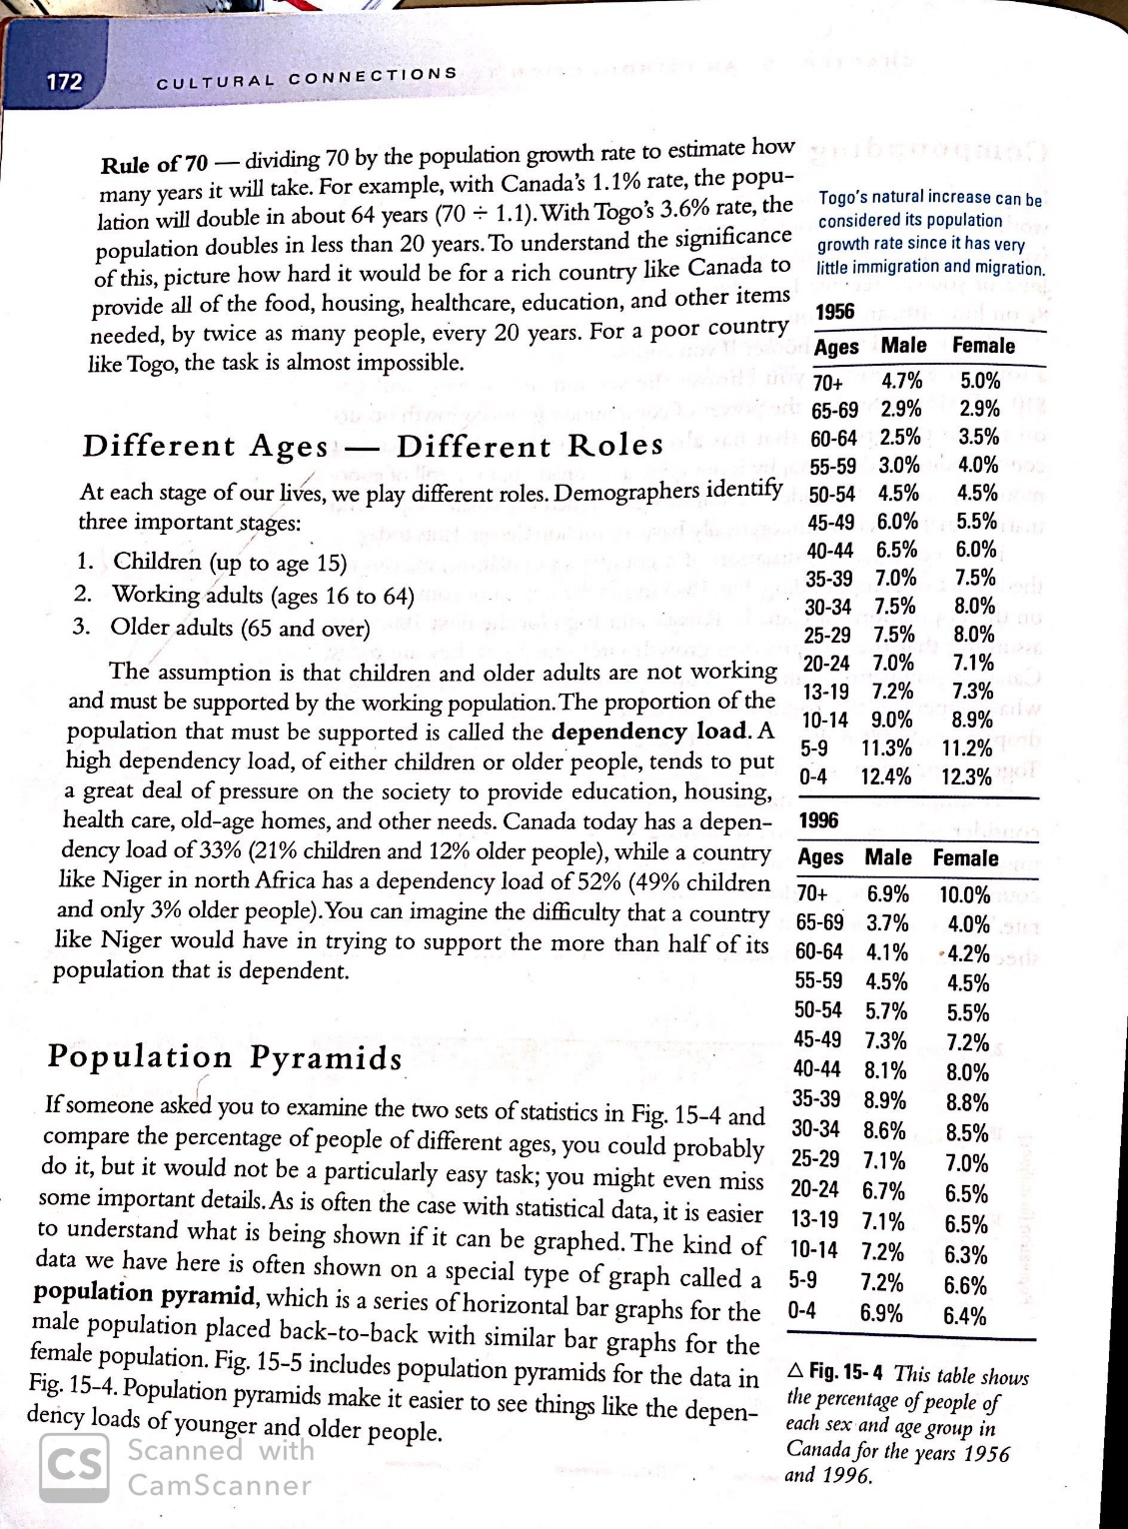

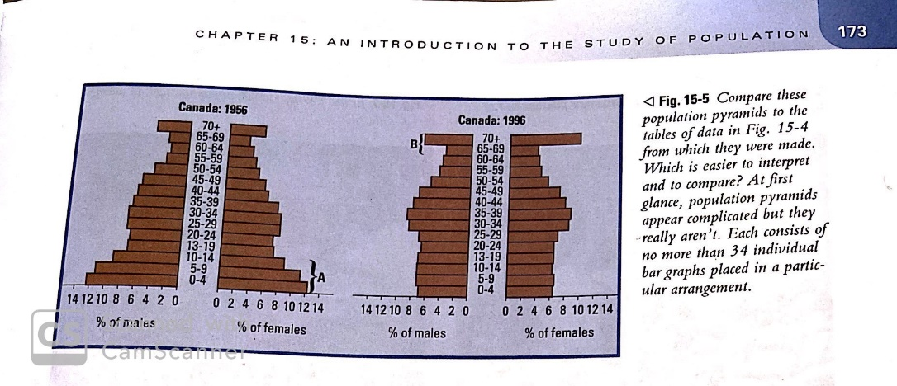

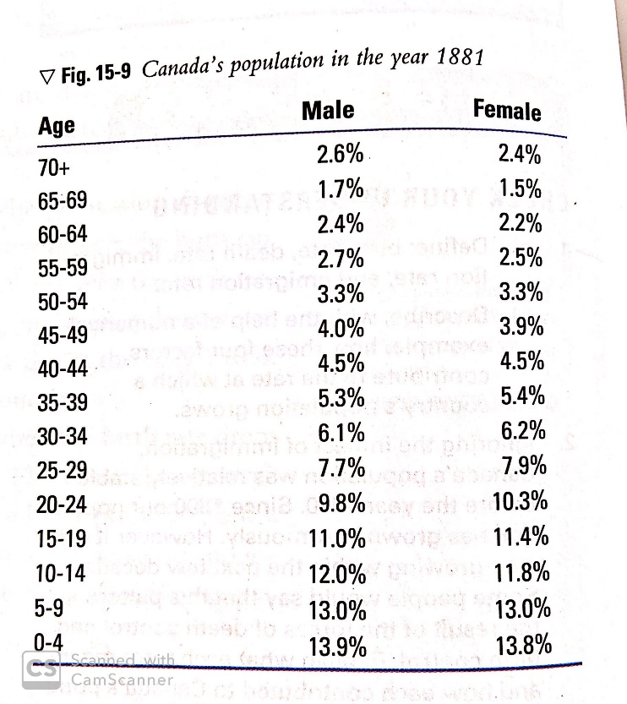
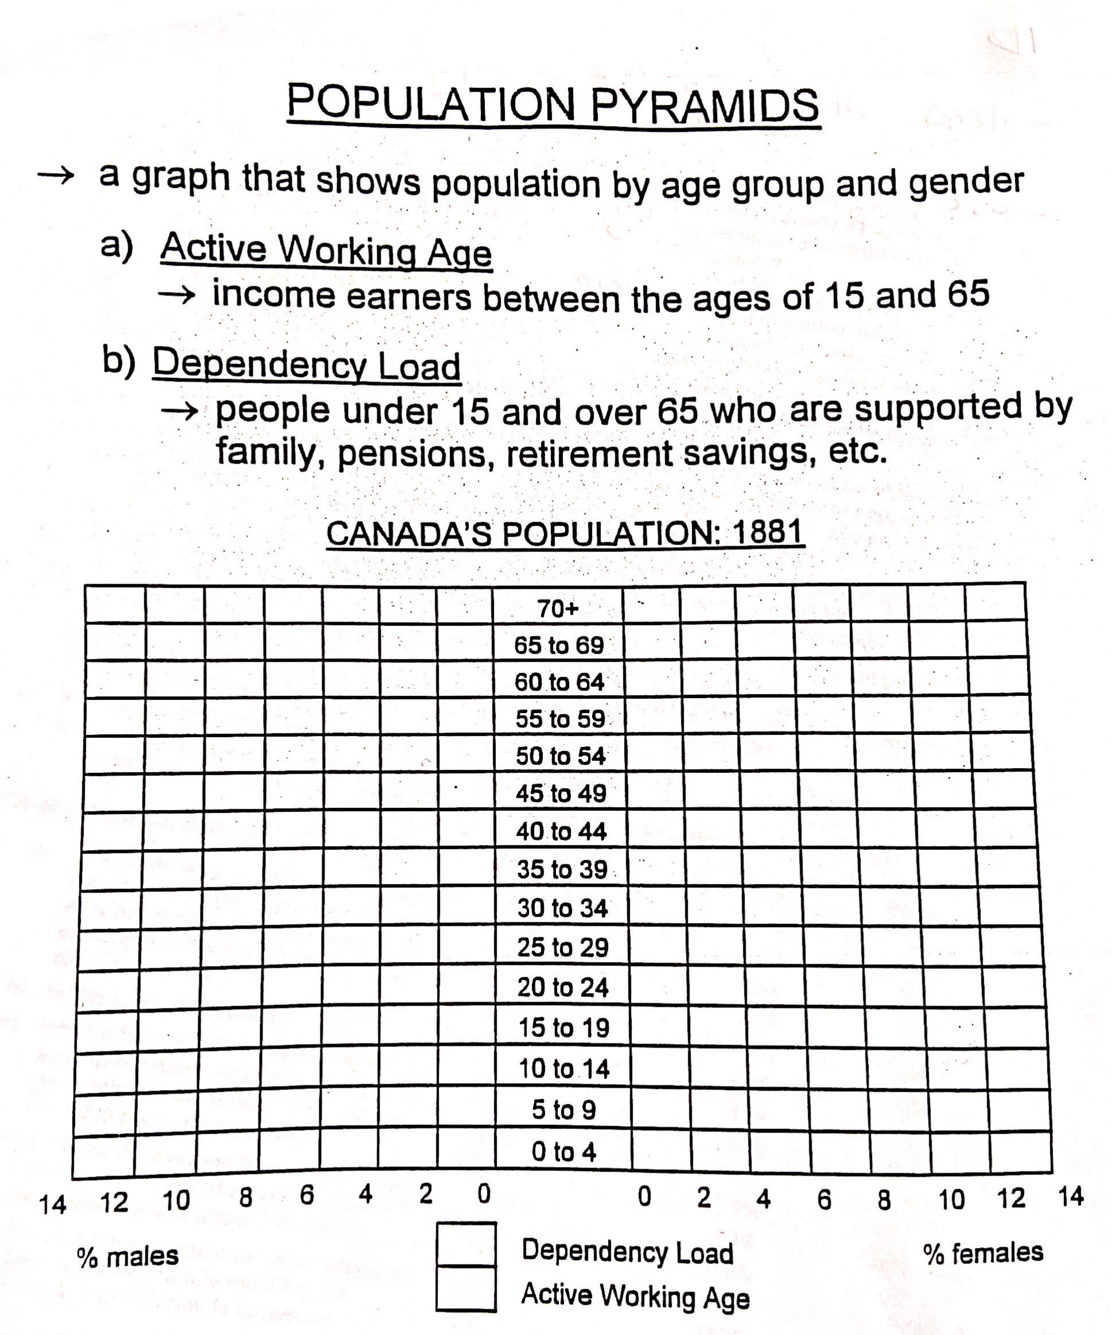PART 2: Complete the population pyramid for 1881
Population Distribution
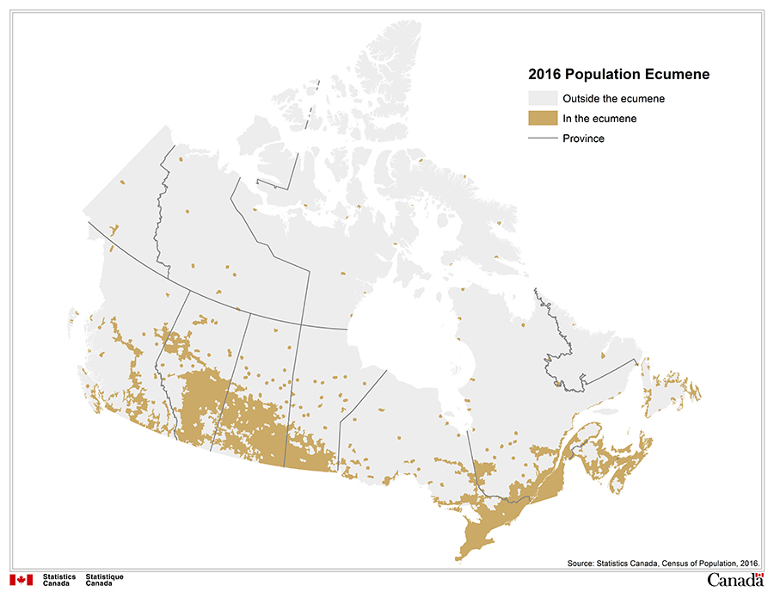
The dots represent people.

POPULATIONS DISTRUBTION describes where people live.
There are THREE major characters of Canadian population distribution:
- _________________ % of Canadians who live within 600km of the US border.
- Majority of Canadians live within ____________________% of Canada’s area.
- _____________% of Canadians live in urban areas.

Look up the information and fill in the blanks. Try to find the most recent data possible.

The following patterns identify different types of settlement patterns. This refers tot eh ways people were organized during settlement of Indigenous lands. Settlement patterns depended on resource management, the natural landscape, and cultural groups maintain their traditional practices. ALL of these patterns can be found in different parts of Canada. You can read more about Settlement Patterns here.
Match the term to the correct settle ment pattern.
- Concentrated
- Evenly distributed
- Unevenly distributed.

Identify an example of each settlement pattern.
- Boreal Shield
- Plains
- Edmonton

Population Density

Population Density is made up of two variables:
- The number of people living in a given area
- The size of the area in square kilometres
Population density is stated as “people per square kilometre” and written as “people/km²
The formula for determining population density is:
population density = population / area sq.km.

Example:
Each square represents the area of 1 sq.km. The number inside the square is the number of people living in that 1 km²
10 | 0 | 2 | 1
5 | 3 | 8 | 20
0 | 15 | 6 | 26
Total area = 4 squares along the top x 3 squares along the side = 4 x 3 = 12 km²
Population = 10 + 2+ 1 + 5 + 3 + 8 + 20 + 15 + 6 + 26 = 96 people
Population Density = People / Area = 96 / 12 = 8 people/km².

You try this one: **make sure you put the appropriate info after each number (km², people, or people/ km².
0 | 4 | 0 | 3 | 0 | 2 | 1 | 0
2 | 0 | 0 | 1 | 5 | 0 | 0 | 0
Total Area = _______________________________________
Population = _______________________________________
Population Density = ______________________________________
Now let’s calculate Canada’s population density using the information you can find here (or Google if that link does not open for you):
Total area: _________________________________________________________________________
Population as of 2020: ________________________________________________________________
Population density: __________________________________________________________________
Where did you get your information? ___________________________________________________________________
The population density that you calculated for Canada is very misleading for people who have little knowledge about Canada’s geography and population distribution. Why? What would people assume when they see Canada’s population density?
________________________________________________________________________________________________________________________________________________________________________________________________________________________________________________________________________________________________________________________________________________________________________________________________________________________________________________________________________________________________
Using resources available to you, identify the five countries with HIGHEST population density and the five countries with the LOWEST population density.
HIGHEST |  | LOWEST
COUNTRY | POP DENSITY | COUNTRY | POP DENSITY

